**Classroom Activity 3:** **Setup BlackBox AI in your VS code and use its features.**

**Step 1: Open VSCode**

1. Open Visual Studio Code (VSCode) on your computer.

**Step 2: Access the Extensions View**

1. Click on the Extensions icon in the Activity Bar on the side of the window. This icon looks like four squares.
2. Alternatively, you can open the Extensions view by pressing Ctrl+Shift+X (Windows/Linux) or Cmd+Shift+X (Mac).

**Step 3: Search for Blackbox**

1. In the Extensions view, type "Blackbox" in the search bar at the top.

**Step 4: Install Blackbox Extension**

1. Find the Blackbox extension in the list of search results.
2. Click the Install button next to the Blackbox extension.

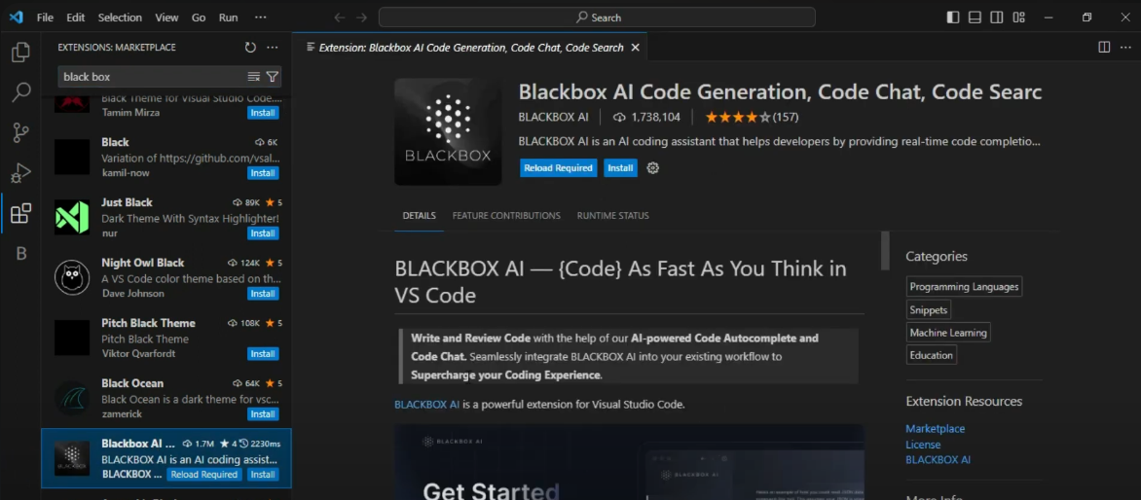

**Step 5: Restart VSCode**

1. It’s often a good idea to restart VSCode after installing new extensions to ensure they are fully integrated.

**Step 6: Debug code.**

* 1. To use the debug feature you can just select the code then right click on it and it will give you option to improve your code.

